Analog Gauge Detection through Camera

**Problem Statement:**

**To extract readings from a picture of an analog circular gauge.**

**Approach 1:**

Idea:

To use computer vision to detect pointing needle and it’s angle and return the values according to the gauge calibration parameters. The image is clicked through a phone through an AR app to provide overlays to click the image best for the image processing algorithm

Steps:

* Using an OpenCV function HoughCircles, we find out the circle all circular constructs found in that image
  + We set a range of radii to detect from and average them out and set the resulting circle (radius, centre coordinates) are the dial gauge
* We then detect the lines using an OpenCV function gough lines
  + The lines used for the detecting the needle need to have a set difference from the centre of circle, the most distant point and nearest point are set as a fraction of the radius (Hough Lines)
  + We then choose the first line from a list of final lines as the approximation of the line of the needle
* Reading the QR code from below the images, the app sends in the gauge number to the firebase database
  + The trigger variable when the image is put into the database is set to ‘False’
  + From there we download the image and gauge number from the database
  + A csv file read the number and puts out the gauge calibration details like the minimum angle, maximum angle of the needle and it’s corresponding values.
  + After getting the values we update the trigger to true and also update the value of the reading

Advantages:

* No need of collecting images for the algorithm to work

Disadvantages:

* The images have to clicked in a very specific manner or the algorithm will not work
* Feature extraction is manual

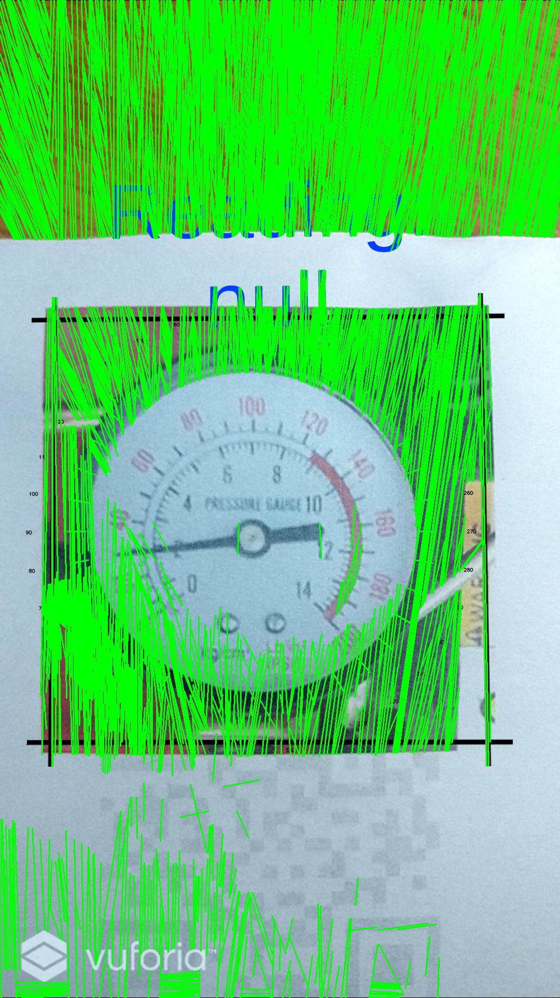

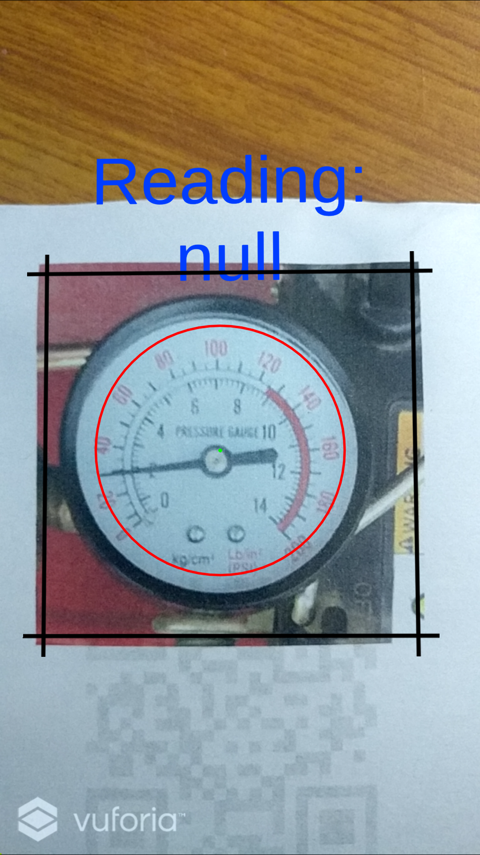

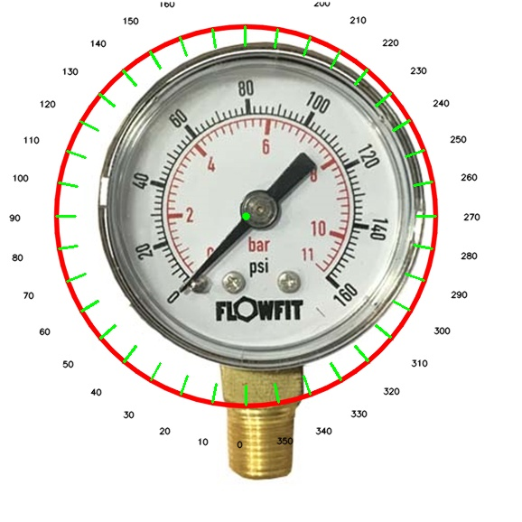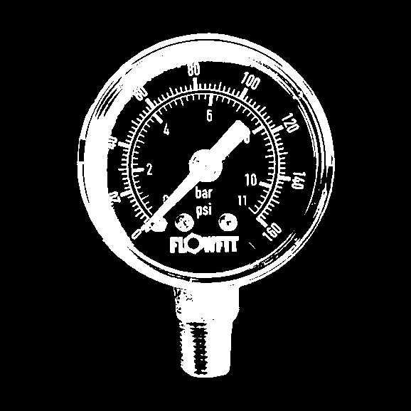

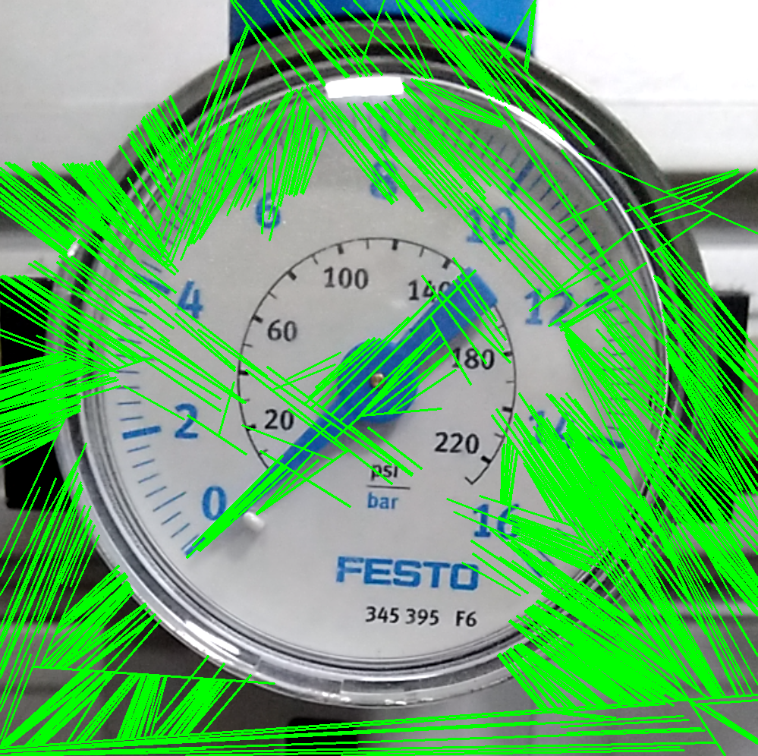

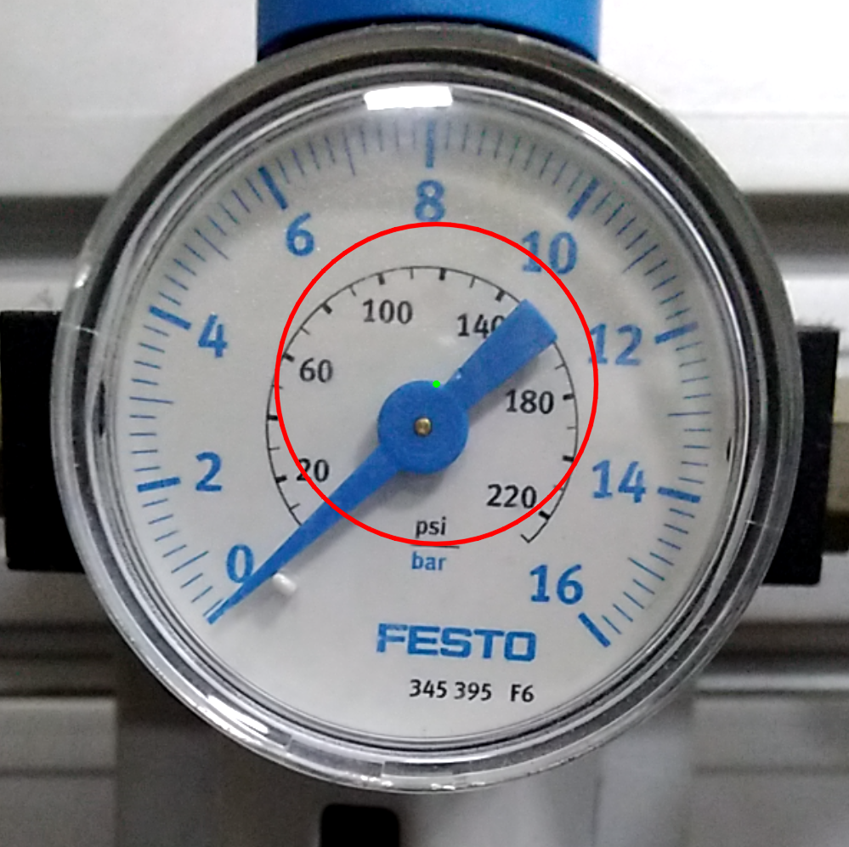

**Approach 2:**

Idea:

Using machine learning and image processing to detect and read the values from analog gauge

Steps:

* Multiples images are captured keeping the camera at a fixed location
* Using OpenCV dataset is generated by separating needle and dial
  + Needle images and dial images are separated out
  + Needle is rotated in various angles and is overlaid on the dial image to generate a synthetic dataset. The angles/rotation step in fixed
  + More image processing like scaling and perspective transform are done
  + Noise is artificially added to make the classifier more robust
* Deep learning classification
  + There are 30 classes to predict each indicating the 30 steps of range of values of the dial
  + Ensemble CNN is used for prediction

Advantages:

* No need to setup manual calibration parameters

Disadvantages:

* Need to have separate needle and dial images beforehand
* Will only work on one type of dial
* Camera needs to be fixed
* Will not be truly analog, but rather

Problems:

* The github code for this approach has their models stored in the cloud, with very less details about the hyperparameters and weights to be replicated.

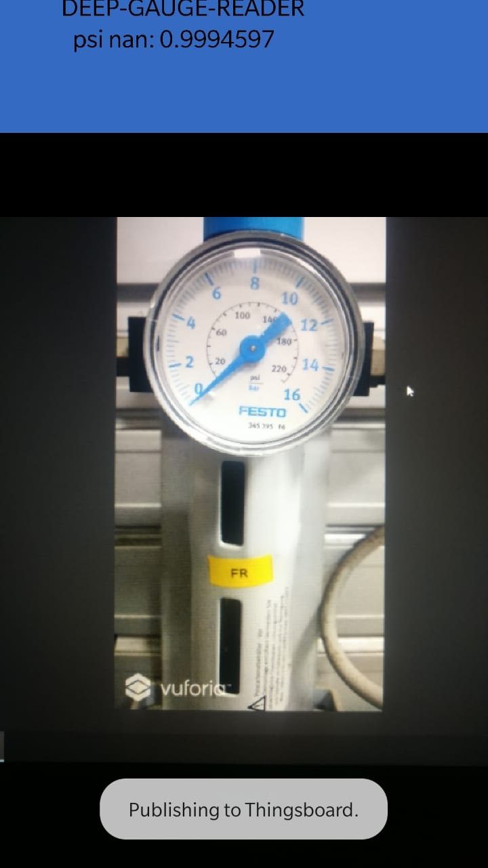

The model was found and was deployed on an app, which has the trained model. It detected value 0 or nan for the classes good in this image, with 99% accuracy.

But other images caused a did not give good results.

To have better results, the idea is to collect atleast 100 to 200 images and train the last layer of the image(transfer learning). Put the trained model, in app, build it again and test it.

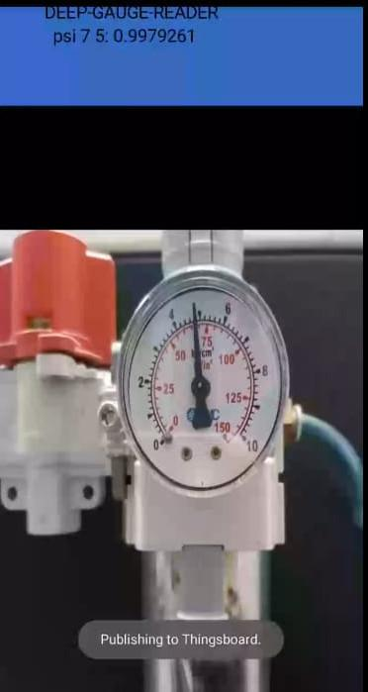

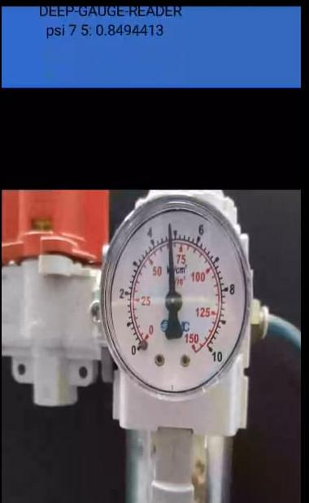

**Approach-3:**

Idea:

To leverage transfer learning and use trained models for reading time of an analog watch and use it for gauge reading.

Steps:

* First we generate dummy clocks for the model to trained on. Here we use the script use to generate it to only produce hour hands for classification.
  + It will be more similar to gauge
* The model detects hour hands and minute hands differently. It uses classification for the hour hand detection and minute hand detection is done through regression.
  + The values are then combined into one final layer and output is predicted.
* In transfer learning we aim to retrain the last layer for our purpose.
  + We initialize it random weights for the last layers weights
  + The training is done through backpropagation. The new dataset is used to train it.
  + The new dataset is made of real gauge pictures with some generated gauge images as well. The classes are also appended. The classes are low, medium, high
  + Details about regression model is not clear, looking into it
  + The image input for network is 57x57 and decreasing images size may loose some information Looking into ways to mitigate this problem

**Approach-4:**

Idea:

To use computer vision to detect the pointing needle and it’s angle and return the values. It determines the pointers and scale indicators automatically and returns the value

Steps:

* Image preprocessing:
  + Filtering out noise and other interference and change from the environment. Using homomorphic filtering method that reduces glare and reflection
  + To correct for the image distortion to caused by different shooting angles, intelligent center point matching is used to correct for the distortion
* Circle detection: (Region Growing method)
  + Most of the dials are white in colour
  + The region with the highest gray level, or the pixel point with the highest gray level is where the dial is. That part is selected as the seed point for region growing
  + Subject to the pixel gray level, the dial region is expanded ??
* Line detection in polar coordinates
  + Image is transformed into polar coordinates, which boosts the dial recognition as well. The image is binarized and
* Scale detection
  + Keeping a mapping of occurence of lines in the scales(outer most lines detected) and plotting in against an angle chart

Problems being faced right now:

* To take into account the image distortion which occurs while taking in an image, one has to go through the various step angles to get the values to automatically match the centre of dial and it’s position in the image. The paper in focus cited another paper on how to achieve calibration, the subsequent trained model (linear SVM + HOG) is not provided
* Isolation of scale marks is a problem right now.
* Segmentation fault, core dumped bug is coming up